--

--



Course: CL1002 – Programming Fundamentals Lab.

Instructor: Sir Muhammad Usman

Submitted by: Muhammad Rehan

Roll no. 22P-9106

Class: BSE-1A (Fall 2022)

Assignment no. 01

Date: September 22th, 2022.

Department of Computer Science

Problem 01:

I’ve used float because mostly temperature values are in decimal point. Using int means less efficient program. I called the function inside the code it makes code more compact and its looks cool.

Code:

//Converts Celsius to Fahrenheit

/\*Float is been used instead of int

because of Accuracy and Precision.

& calculation is limited in int.

and C to F conversion gives

result in decimal point\*/

#include<stdio.h>

float celsiusToFahrenheit(float celsius);

int main()

{

float celsius;

printf("\nEnter the Celsius value: ");

scanf("%f",&celsius);

//Calling function inside of printf to improve code efficiency

printf("\nThe Value in Fahrenheit is: %.2f F\n\n",celsiusToFahrenheit(celsius));

return 0;

}

// A Function which converts Celsius to Fahrenheit.

float celsiusToFahrenheit(float celsius)

{

return (celsius\*9/5+32);

}

Screenshots:

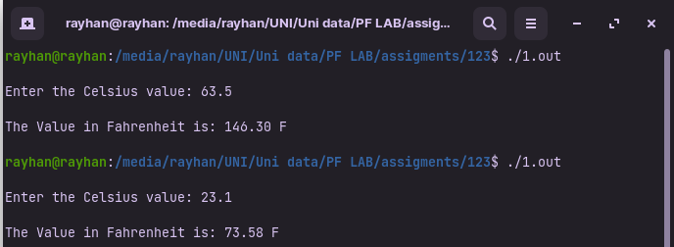

Problem 02:

Main function will input the value and give it to function which will then determine whether it’s a leap year or not.

Code:

//Program to Check whether is leap or not.

#include<stdio.h>

void isleap(int year);

int main()

{

int year;

printf("\nEnter the year : ");

scanf("%d",&year);

isleap(year);

return 0;

}

void isleap(int year)

//Above function will determine whether a year is leap or not.

//Using nested if-else.

{

//Checking if its a century year

if (year%100==0)

{

//if its a Century year then it's divisible by 400.

    if(year%400==0)

    {

    printf("\n%d is leap year.\n\n",year);

    }

else

    {

    printf("\n%d isn't a leap year.\n\n",year);

    }

}

else

{

//if it isn’t a Century year then it's divisible by 4.

    if(year%4==0)

    {

    printf("\n%d is a leap yaer.\n\n",year);

    }

    else

    {

    printf("\n%d is not a leap year.\n\n",year);

    }

}}

Screenshot:

